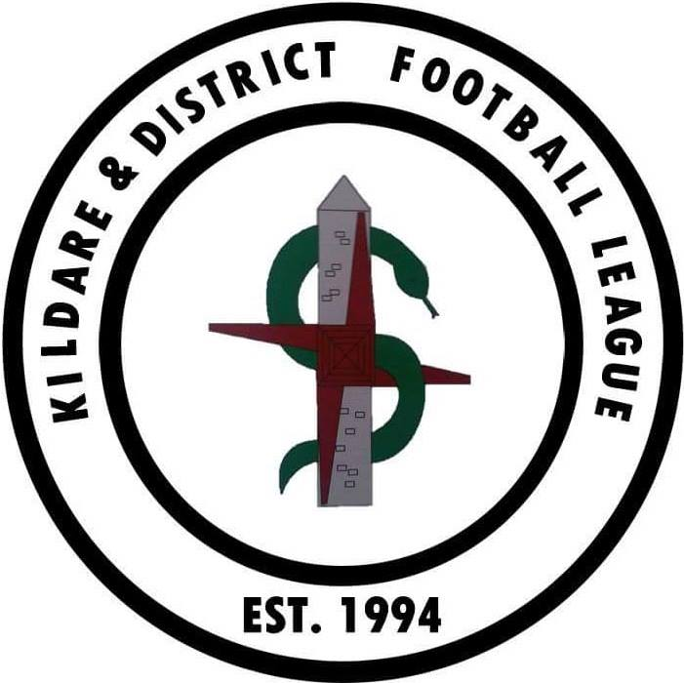

2022 KDFL ROLL OF HONOUR AT 25TH NOV 2022

COMPETITION | WINNERS | RUNNERS UP | Presented by
SENIOR LEAGUE | CLONMULLION FC | ATHY TOWN AFC | Tony Martin
PREMIER LEAGUE | ARLINGTON FC | NEWBRIDGE HOTSPURS FC | Katie Downey  & Tina Preston
DIV 1 LEAGUE | OLD FORT CELTIC FC | NEWBRIDGE UNITED FC | Tommy Stanley
DIV 2 LEAGUE | CLONMULLION AFC | ATHY TOWN AFC | Noel Hill
MASTERS LEAGUE DIV 1 | NEWBRIDGE TOWN FC | MAYNOOTH TOWN AFC | Regina Casey
MASTERS LEAGUE DIV 2 | ARLINGTON FC | STRAFFAN AFC | Brian Reilly
WOMENS LEAGUE | SALLINS CELTIC FC | MONASTEREVIN AFC | Peter Doyle
SENIOR CUP | CLONMULLION FC | COILL DUBH AFC | Michael Casey
PREMIER CUP | STRAFFAN AFC | ARLINGTON FC | Karen Hickey
DIV 1 CUP | NEWBRIDGE UNITED FC | COILL DUBH AFC | William Healy
DIV 2 CUP | ATHY TOWN AFC | OLD FORT CELTIC FC | Gerry Gorman
MASTERS CUP | NEWBRIDGE TOWN FC | CELBRIDGE TOWN FC | Tony O Dowd
WOMENS CUP | SALLINS CELTIC FC | MONASTEREVIN AFC | Pat Behan
LEAGUE CUP | CLONMULLION FC | CLANE UNITED FC | Mick & Gerry
LEAGUE SHIELD | STRAFFAN AFC | ATHY TOWN AFC | Hollie Casey
MASTERS SHIELD | LEIXLIP UNITED FC | MONASTEREVIN AFC | Eric McCann
WOMENS SHIELD | RATHANGAN AFC | EDENDERRY TOWN FC | Danielle Hickey

Special Award winners
Award | Winner | Club | Presented by
Masters Div 2 POY | Ronan Stafford | Monasterevin AFC | Pat Costello
Masters Div 1 POY | Ray Coleman | Newbridge Town AFC | Pat Costello
Womens Div POY | Amy Moran | Kilcullen AFC | Wayne Long
Div 2 POY | Dylan Barnby | Athy Town AFC | Tony Martin
Div 1 POY | Conor Dowling | Old Fort Celtic FC | Tony Martin
Premier Div POY | Alan Campbell | Caragh Celtic FC | Hollie Casey
Senior Div POY | Johnny Fennell | Clonmullion FC | Tommy Stanley
Manager of the Year | Brian Kenny & Barry Hughes | Clonmullion FC | Karen Hickey
Photo of the Year | Donal Harrison | Monasterevin AFC | Regina Casey
League Cup MOM | Jody Dillon | Clonmullion FC | Ciaran Hannigan
Fair Play Award | Straffan AFC |  | Martin Moloney
PRO Of the Year | Daniel Bland | Old Fort Celtic | Tommy Callaghan
In Appreciation | Tommy Callaghan | Leinster Leader | Michael Casey
Special Merit Award | Clane United |  | Karen Hickey
GK Of the Year | Luke Anderson | Coill Dubh AFC | Michael Casey
Young POY | Lee Day | Clonmullion FC | Hollie Casey
Womens POY | Alice Breen | Monasterevin AFC | Peter Doyle
Player of the Year | Eoghan Maguire | Clane United FC | Tommy Stanley
Special Service Award | Kevin Higgins | Ballycane Celtic FC | Regina Casey
Club of the Year | Clonmullion AFC |  | Mick & Gerry

FAI CENTENARY AWARD
WINNER | Freddie Mitchell | Kilcullen AFC | Gerry McAnaney
Nominees | Paudie Sullivan | Coill Dubh AFC | Gerry McAnaney
 | Kevin Higgins | Ballycane Celtic FC | Gerry McAnaney
 | Liam Murphy | Castle Villa AFC | Gerry McAnaney
 | Richard Confrey | Arlington FC | Gerry McAnaney
 | Tom Kearney | Athy Town AFC | Gerry McAnaney
 | Mark Doyle | Rathangan AFC | Gerry McAnaney
 | Josie Dunne | Suncroft AFC | Gerry McAnaney
 | Martin Byrne | Kilcock Celtic FC | Gerry McAnaney

